**MAIN COMBUSTION CHAMBER DESIGN**

Closed Expander Cycle

The closed expander cycle refers to the cycle where all propellants that enter into the engine leave by going through the throat of the main combustion chamber thus yielding the greatest chemical efficiency.

The closed expander cycle is one of the simplest engine cycles.

Closed Expander Cycle Illustration

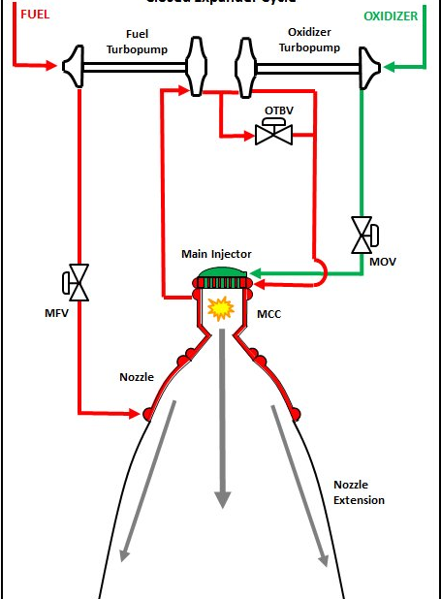

**NOZZLE DESIGN**

Objectives

1. To establish the most efficient nozzle geometry that will maximize pressure while minimizing pressure drops.
2. To integrate cooling system to the nozzle and combustion chamber
3. To develop a CAD model of the nozzle with cooling and combustion chamber
4. To come up with ANSYS/ABAQUS/COMSOL Multiphysics simulations

Theory

* **Introduction**

Conclusion

It was established, from experiments conducted on 27 different nozzle geometries divided into two groups – conical and parabolic nozzles, that a smaller diverging angle and absence of an elongated throat resulted in a higher critical pressure ratio.

References

1. [nasa blog](https://blogs.nasa.gov/J2X/tag/main-combustion-chamber/)
2. <https://www.sciencedirect.com/science/article/pii/S2405844018374164#:~:text=An%20optimum%20nozzle%20geometry%20is,compared%20to%20other%20nozzle%20geometries.&text=Almeida%20(2015)%20investigated%20the%20effect,diverging%20section)%20on%20nozzle%20performance.>